Exercise : MERN Deployment Setup

Firebase Hosting Initial Setup
You need a Google account to work with Firebase. Go to https://firebase.google.com and click Go to console in the top-right corner. You must be logged in to your Google account to do so.
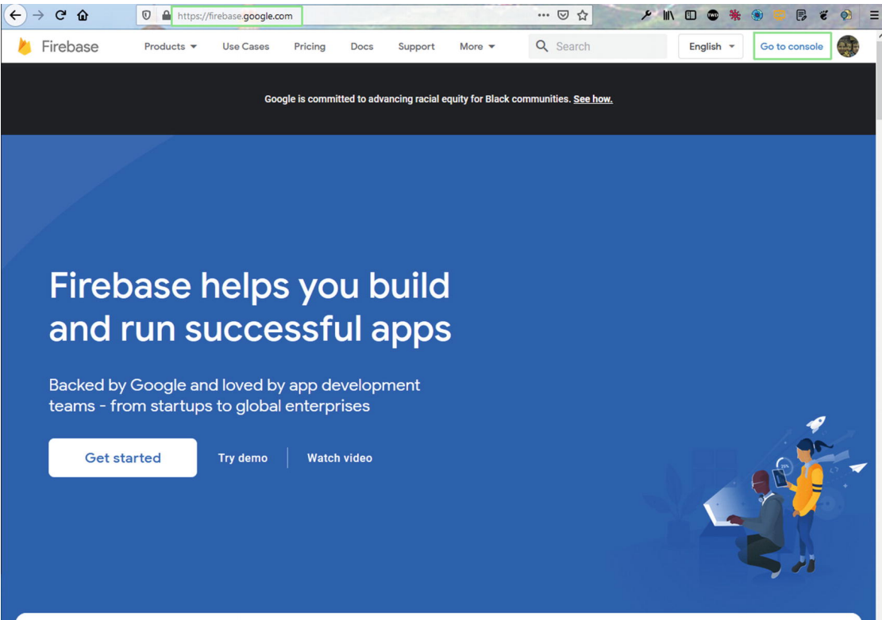
Click the Add project link on the page
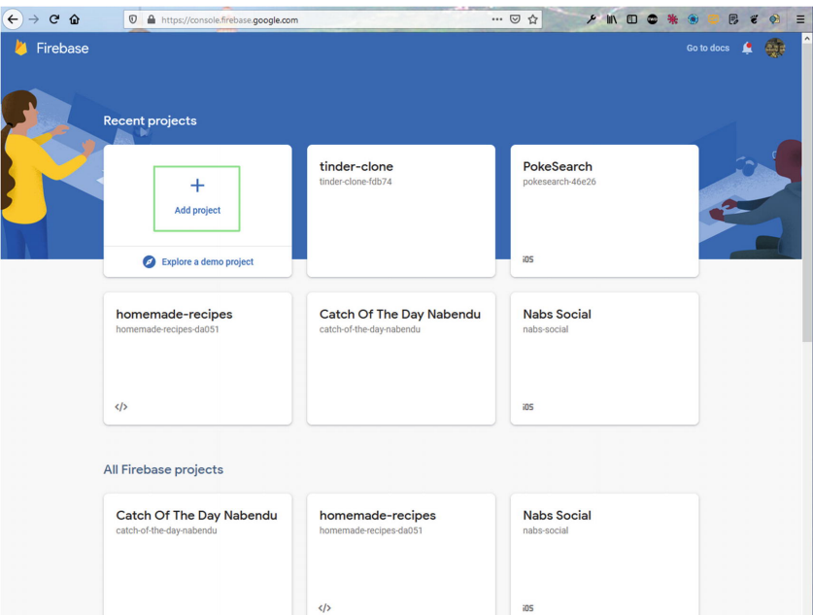
On this page, name the project dating-app-mern, and then click the Continue button. Note that this is just an installation instruction.
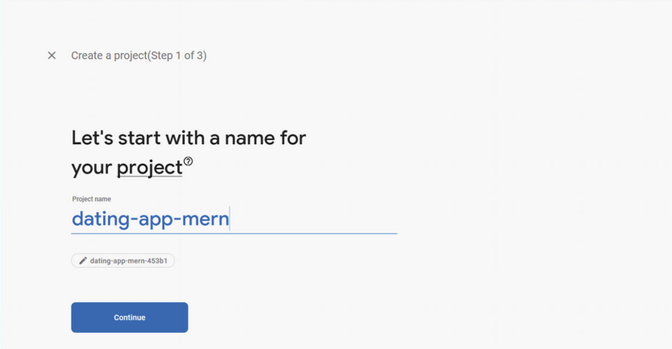
On the next page, click the Create project button
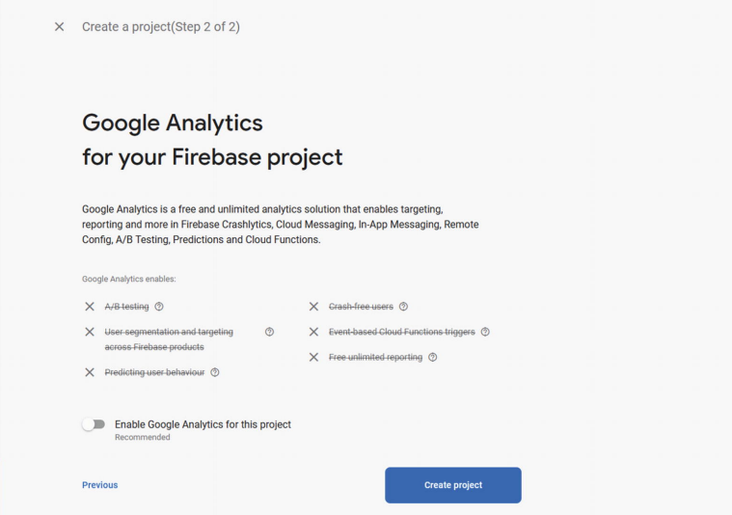
It takes some time to create the project


MongoDB Setup
MongoDB is the database that you work with on the cloud. It is also known as MongoDB Atlas. This is easier to work with than setting up on a local machine. Go to www.mongodb.com and log in or create a new account.

Creating a New Project
After logging in. Click the New Project button.
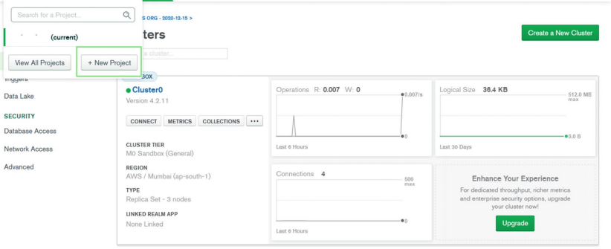
Name your project dating-app-mern, and then click the Next button
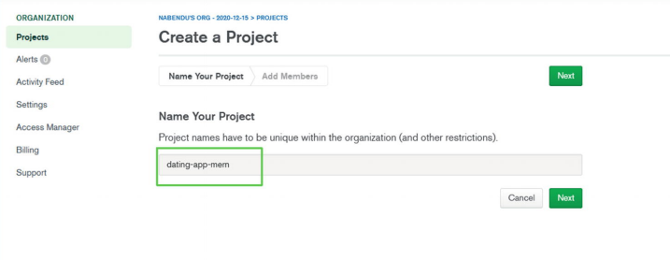
On the next screen, click the Create Project button
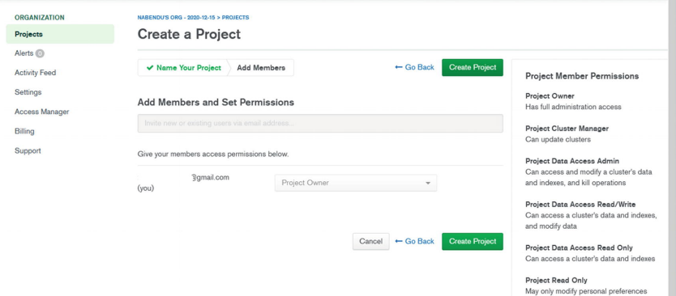
On the next screen, click the Build a Cluster button
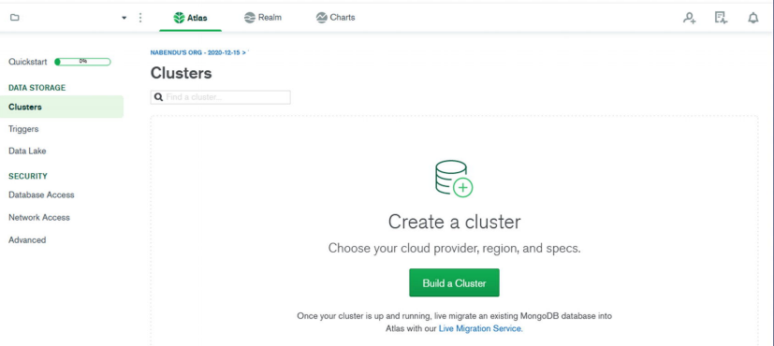
On the next screen, select the Free tier
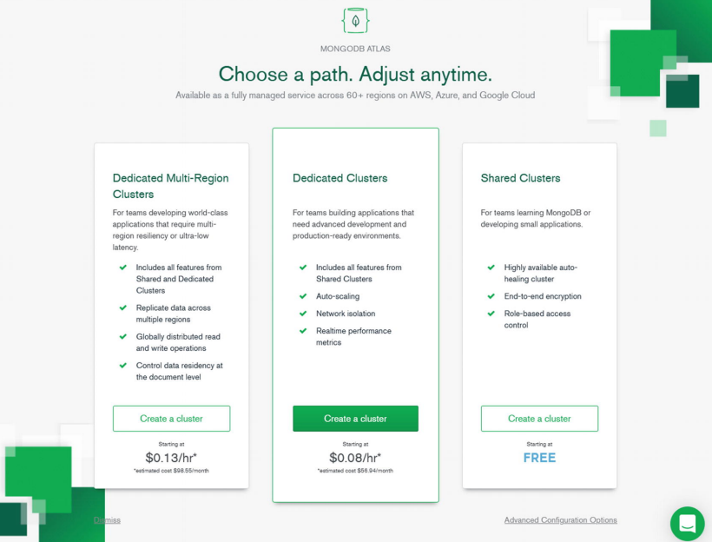
On the next screen, you need to choose the AWS region in which to create the database. (I chose Singapore because I live in VietNam, and this gives me low latency.) Afterward, click the Create Cluster button
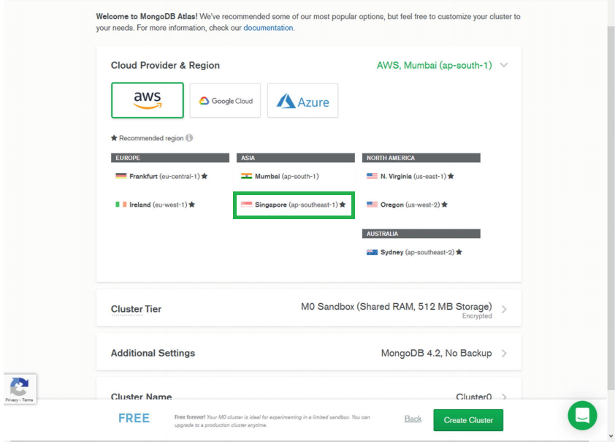
The next screen shows that the cluster has been created, which takes time. You can go back and create your.
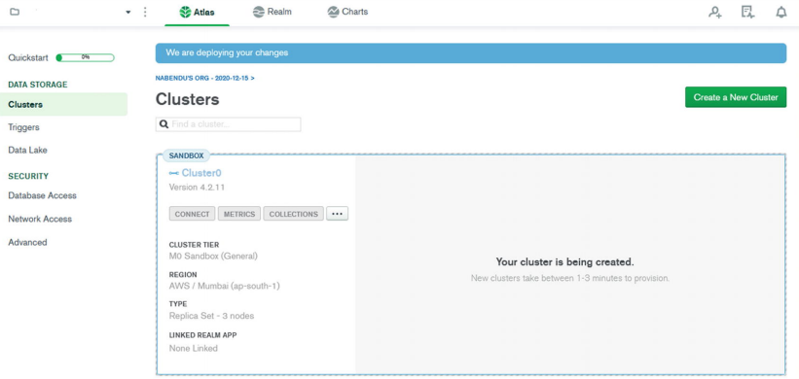

Database User and Network Access
To create a user in MongoDB, click the Database Access tab and then the Add New Database User button
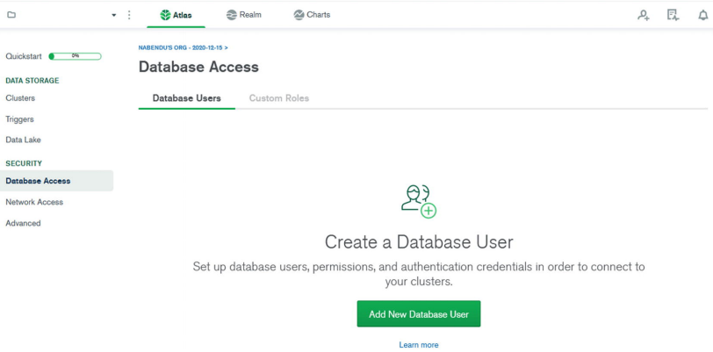
On the next screen, you need to enter a username and a password. You must remember both. Next, scroll down and click the Add User button.
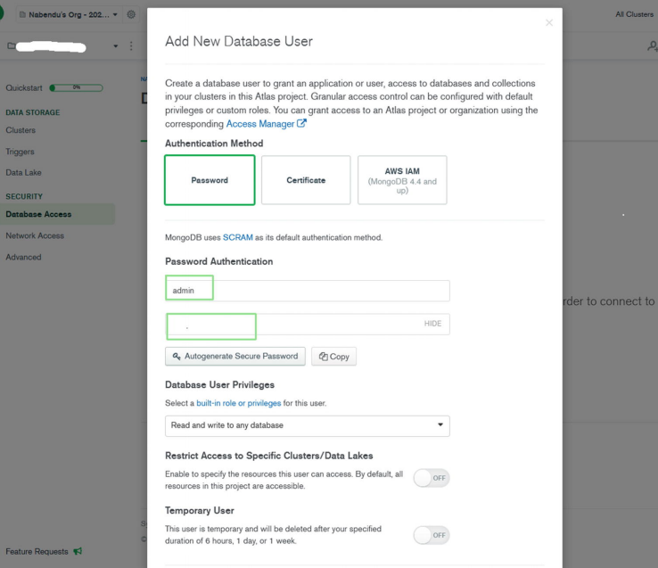
Next, go to the Network Access tab and click the Add IP Address button
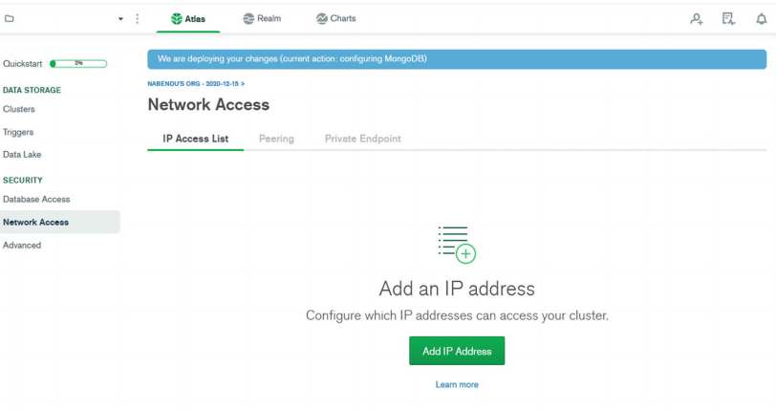
In the popup window, click the ALLOW ACCESS FROM ANYWHERE button and then click the Confirm button
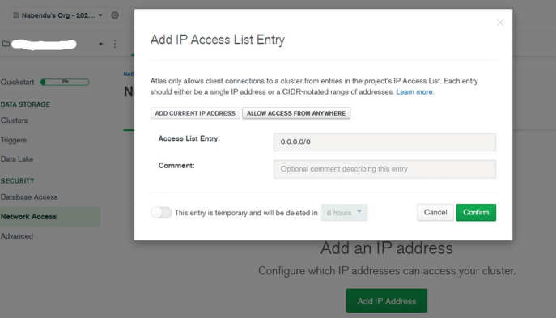
Next, return to the Cluster tab and click the CONNECT button, which opens the popup window. Click the Connect your application tab
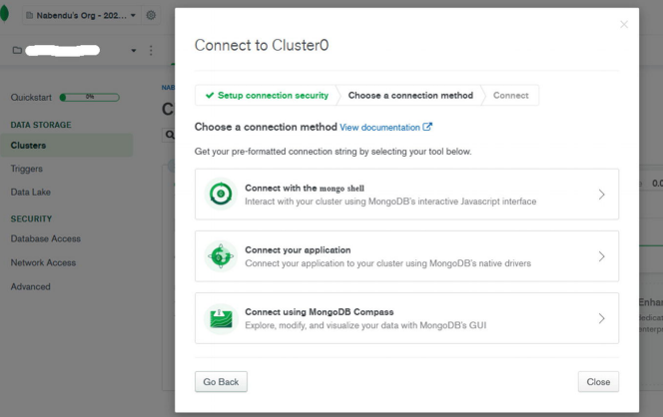
Copy the connection URL by clicking the Copy button
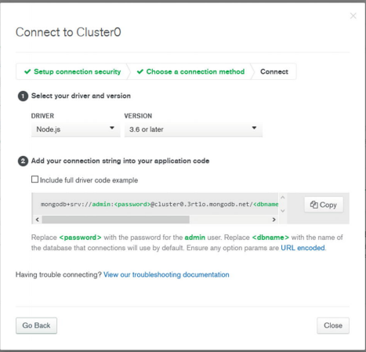

Deploying the Back End to Heroku
Once you complete the back-end code, go to www.heroku.com to deploy the back end. Log in to your Heroku account, click the New drop-down menu, and then click the Create new app button. You can also do this from the command line using the Heroku CLI, but that is not covered here.
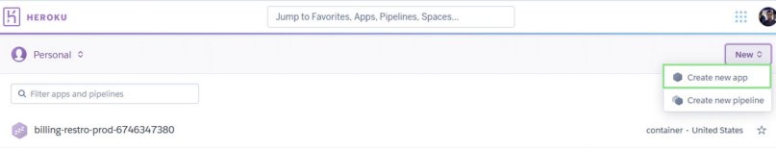
Next, name the app and click the Create app button
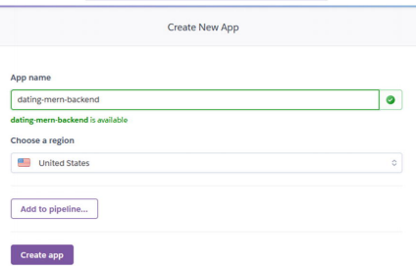
The next screen shows all the commands to deploy your app, but you need the Heroku CLI. Click the link and follow the instructions to install it on your operating system.
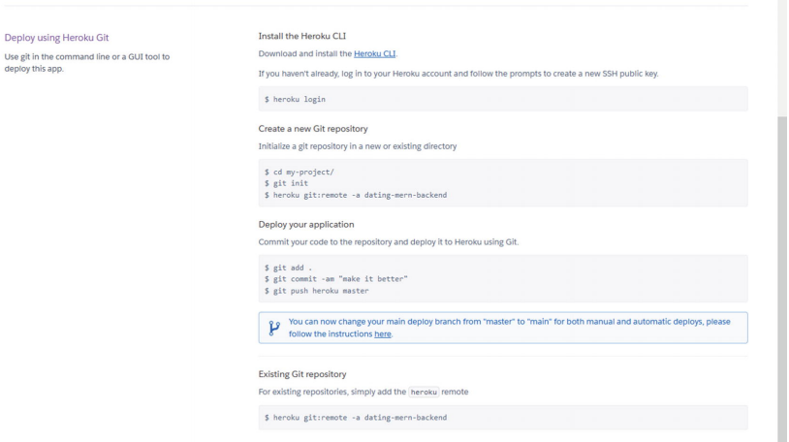
Run the heroku login command in the backend folder. You are asked for permission to open the browser. This command asks you to press any key to open in the browser.
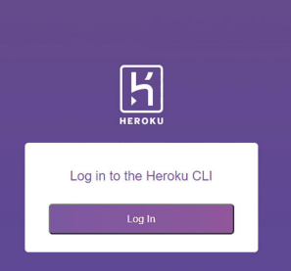
Here, you can log in with your credentials
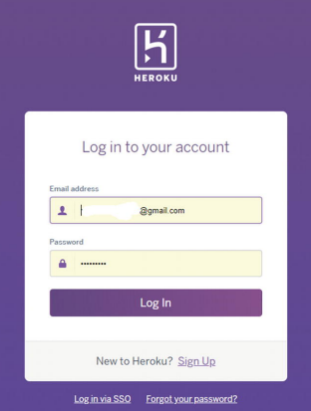
After successfully logging in, you see the page, which you need to close.
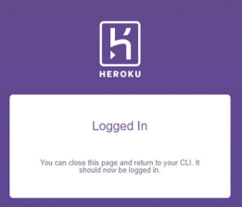
You need to push the code from your local machine to the Heroku repository. Now that you are logged in to your account, you can run the following command to connect to Heroku Git.
heroku git:remote -a dating-mern-backend
Next, let’s run the familiar git command to commit the code. Now, Git is software that tracks changes in add code to the staging area, then commits it. The push command pushes it to remote Heroku servers. git add .
git commit -m "backend code complete"
git push heroku master
After the installation is done, click the Open app button, which takes you to the deploy site
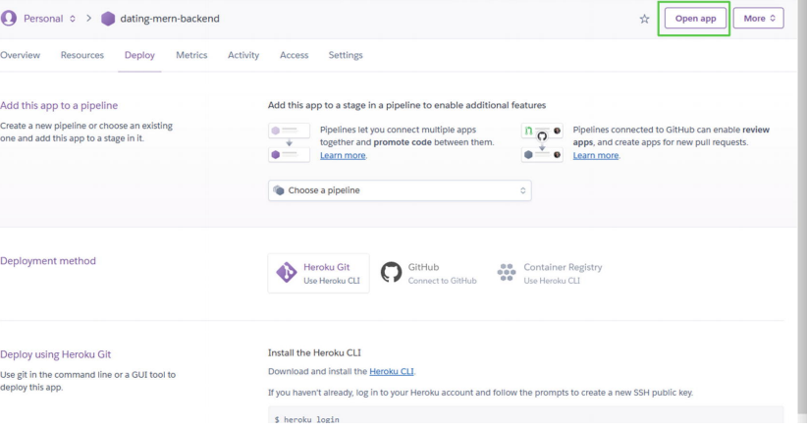

Deploying the Front End to Firebase
After the front-end project is complete, you can deploy it in Firebase. Go to the frontend folder and run the firebase login command in the terminal. If you are running it for the first time, a popup window opens. Next, run the firebase init command. Type Y to proceed.
firebase login
firebase init
Use the down arrow key to go to Hosting. Press the spacebar to select it, and then press the Enter key.
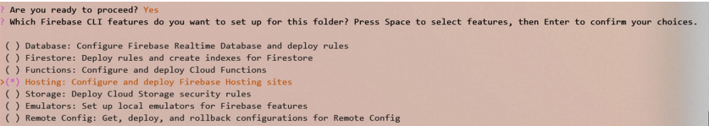
Select Use an existing project and press the Enter key
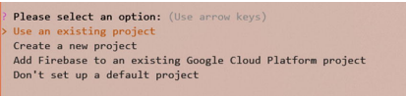
Next, select the correct project, which is dating-app-mern-453b1 in my case
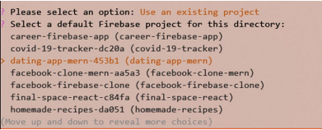
Next, choose the public directory, which is build. The following question asks about a single-page app; answer Yes. The next question is about GitHub deploys; answer No.
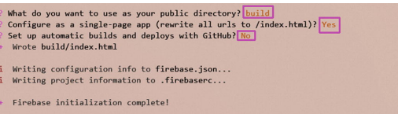
Next, run npm run build in the frontend folder for an optimal production build. The final command, firebase deploy, deploys the project to Firebase. If successful, the site is now live.

